BID-501 Python for Bioinformatics

**Assignment 6**

Practical Solving:

Perform the following questions using functions

1. Write a program to determine whether the number entered is Armstrong or not (should not be restricted to no. of digits)

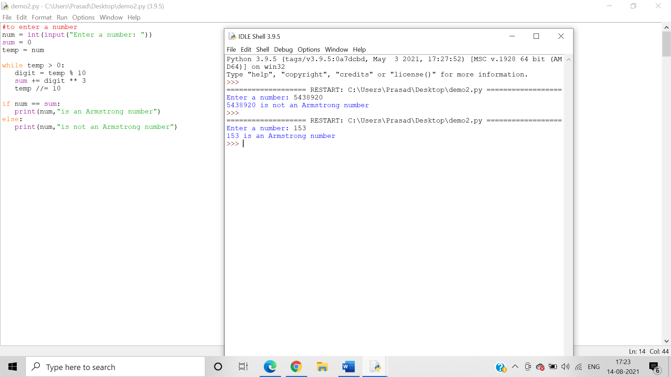

2. Write a program to calculate the factorial of the number entered by the user(function recursion)

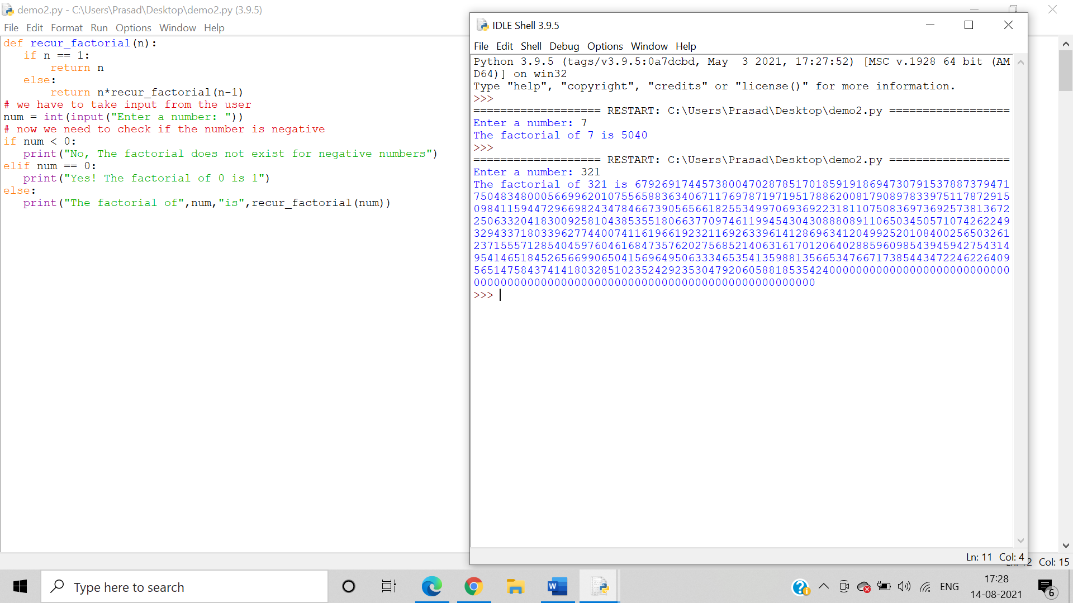

3.Print all odd and even numbers separately entered in the user defined range (Use Lambda function)

Even Numbers:

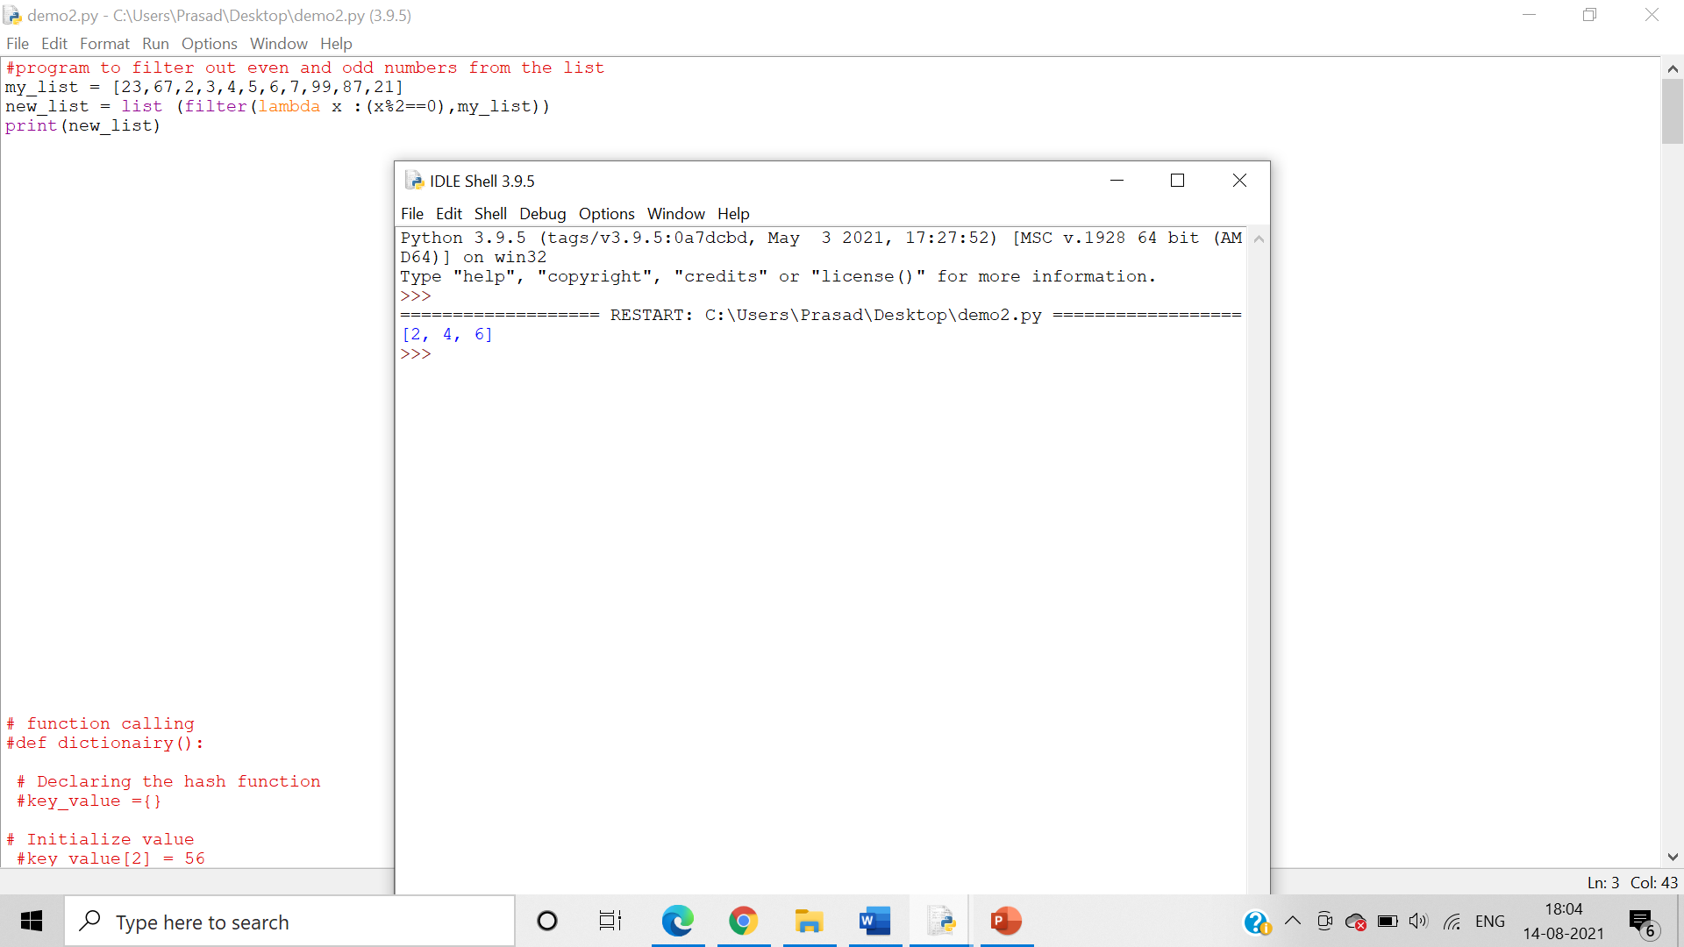

Odd Numbers:

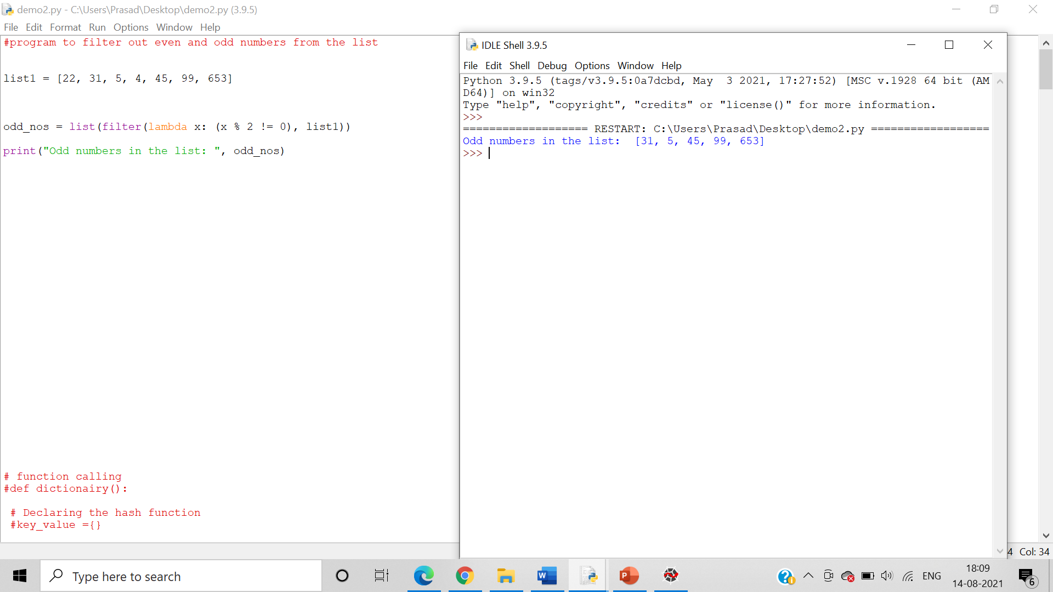

4. Write a program to create grade calculator using dictionaries

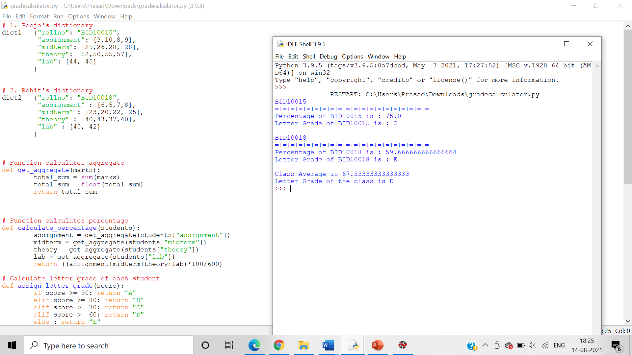

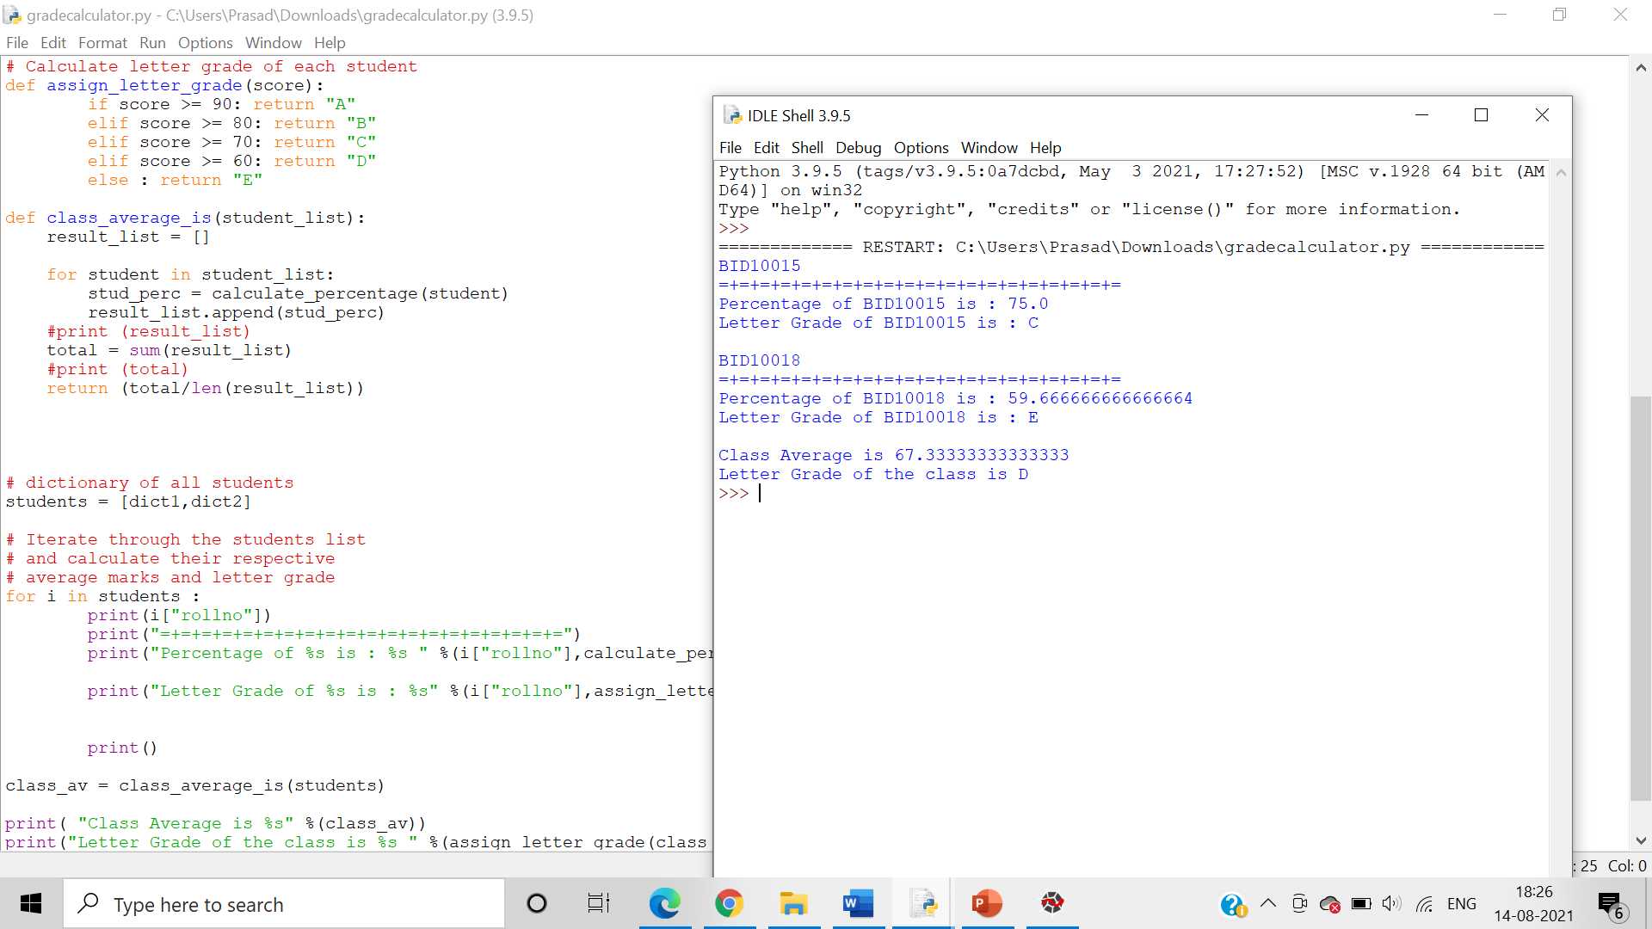

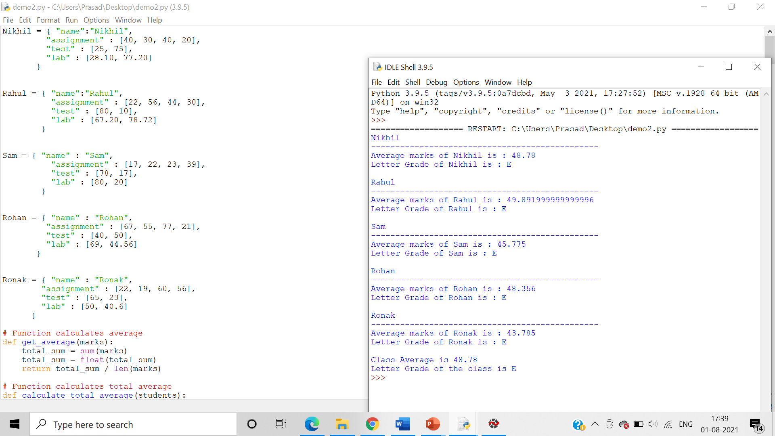

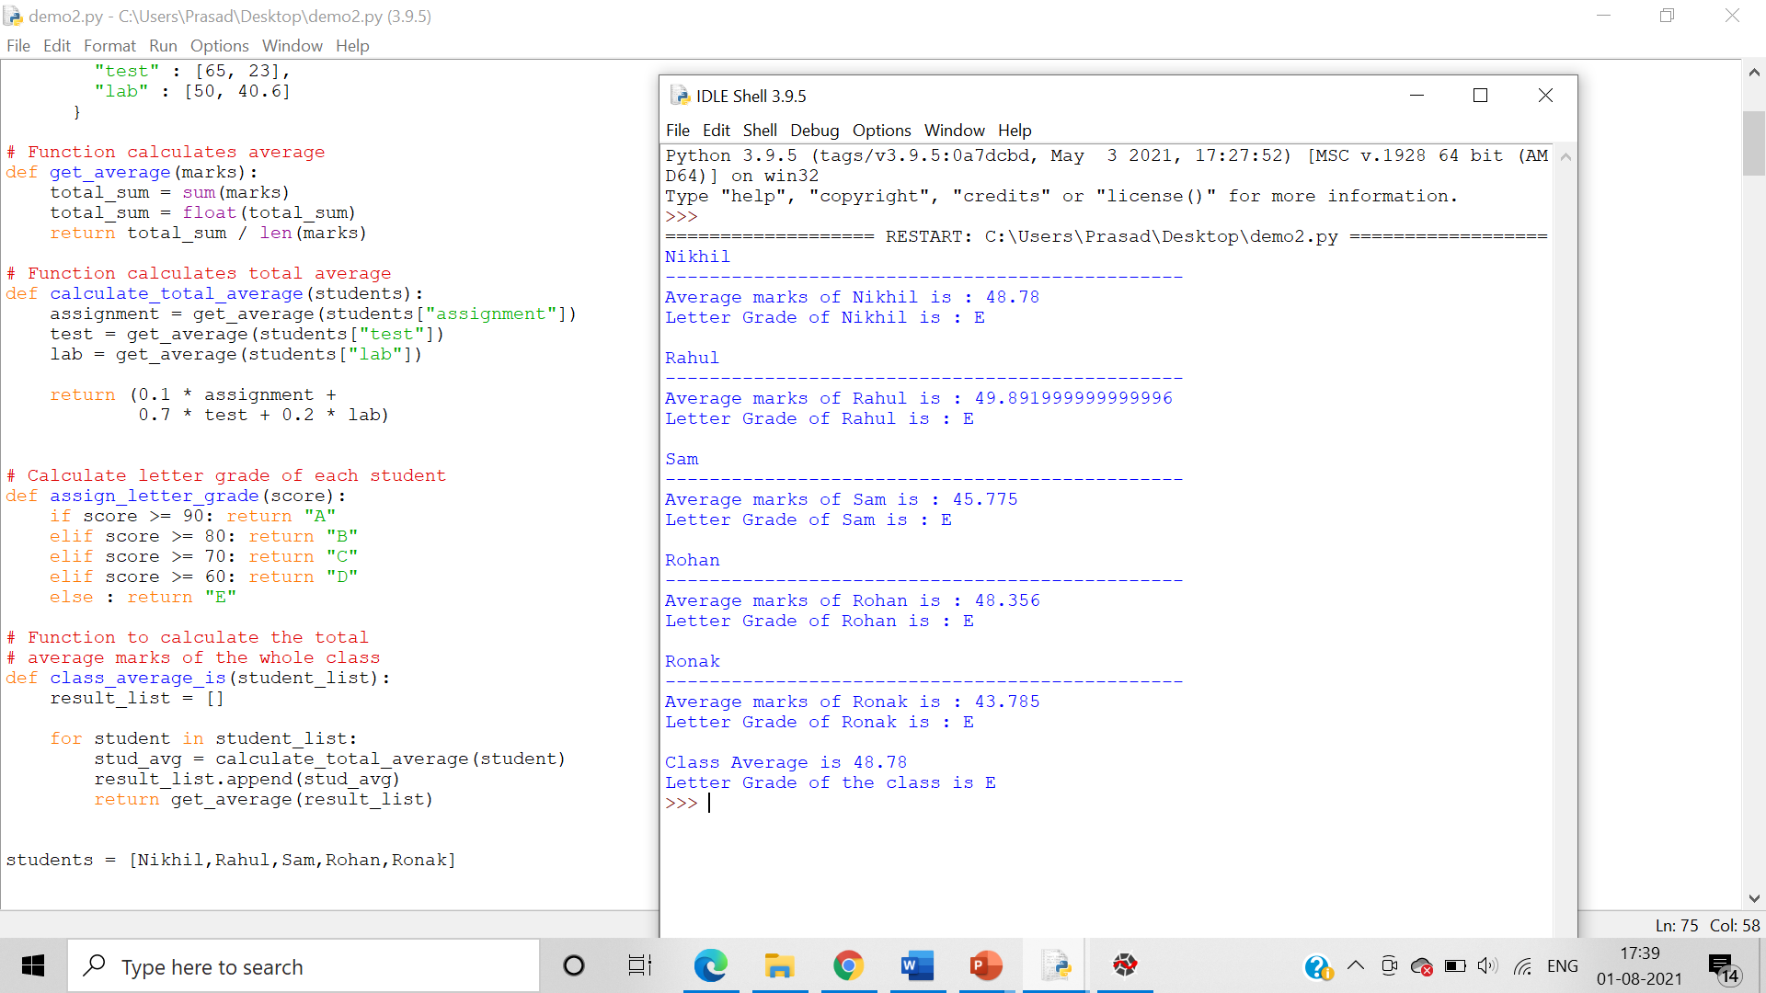

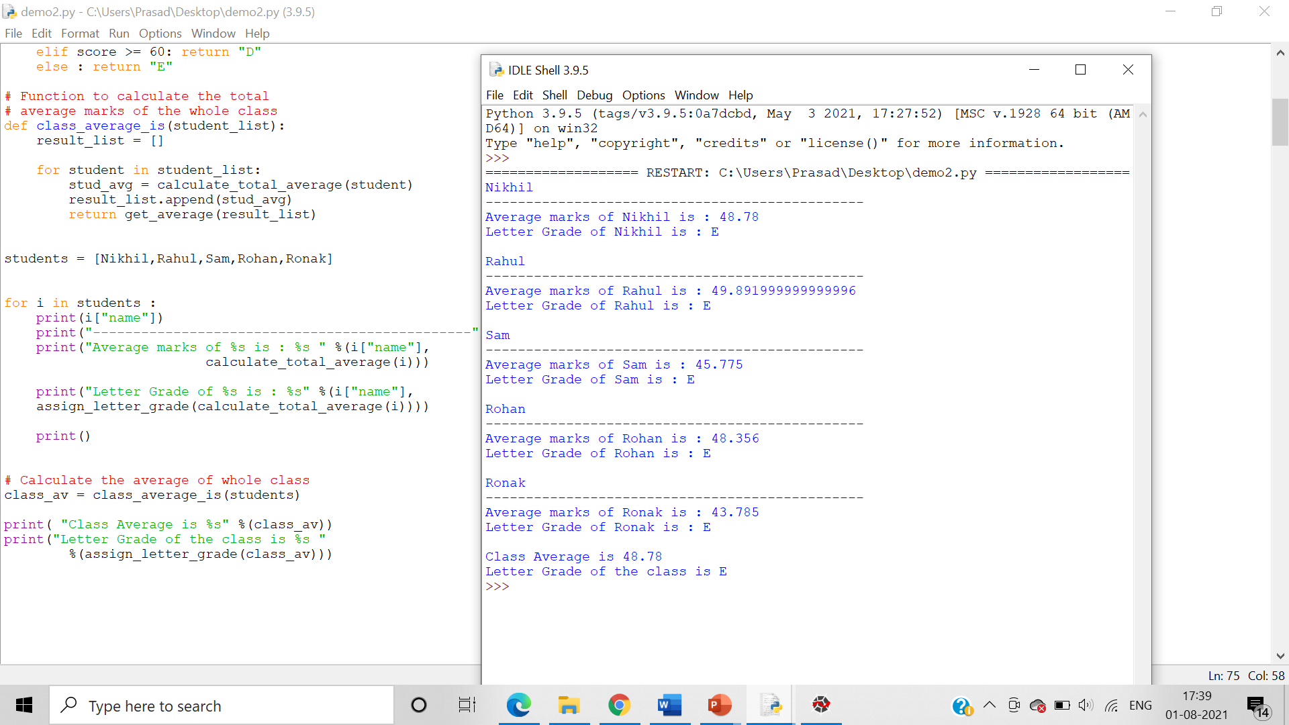

5. Write a program to calculate the frequency of bases in the DNA sequence submitted by the user and calculate GC percentage (create function)

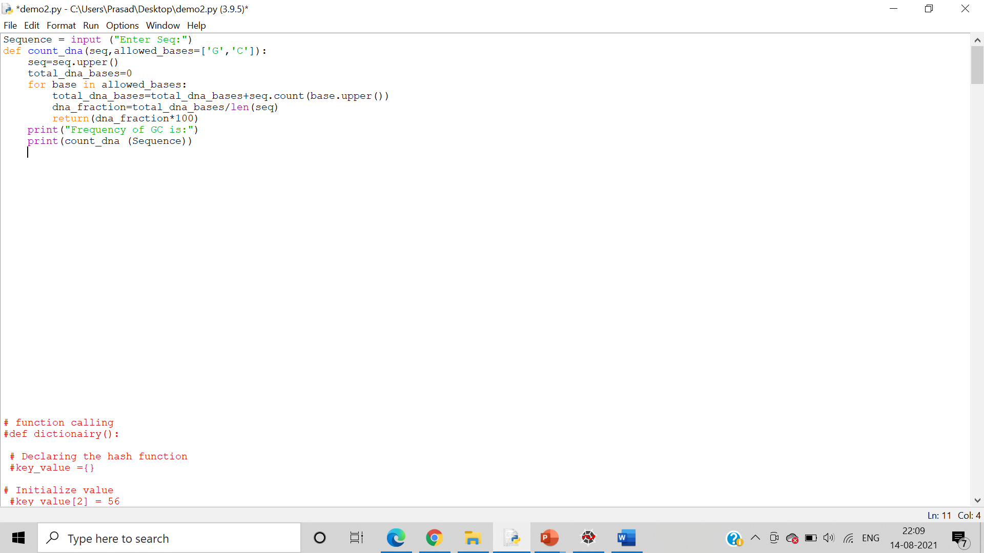

6.Write a program to calculate Molecular weight of the peptide sequence submitted by the user

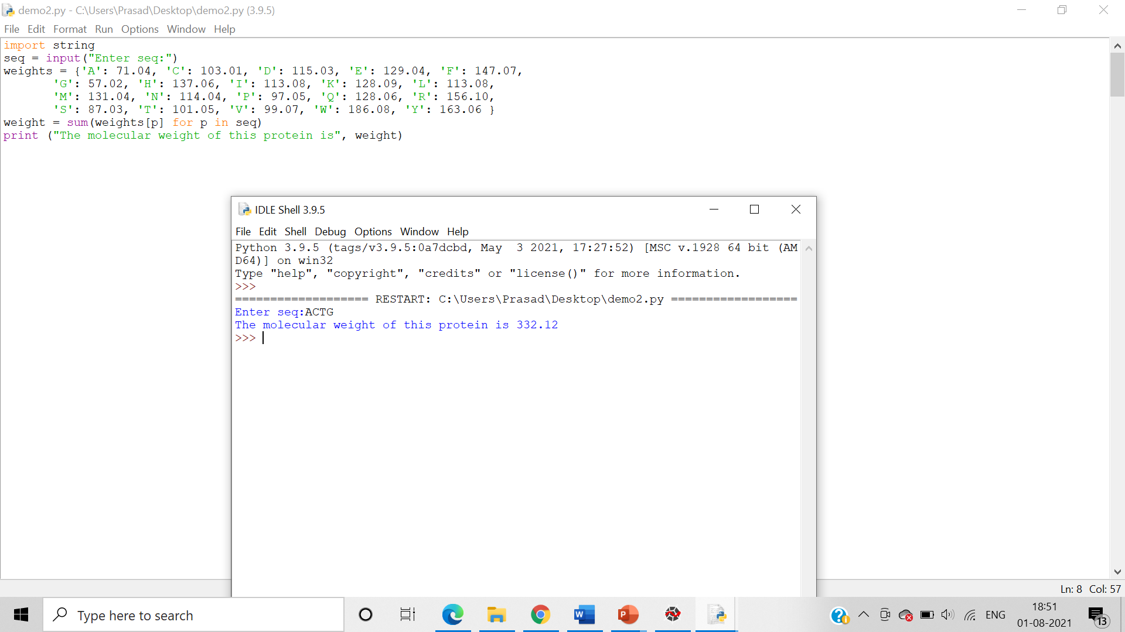

7.Create a package incorporating GC percentage module along with calculation of Molecular Weight of peptide sequence

8.Create a package having functionalities for calculation of shapes of 2D and 3D structures as given in the following image